**The optical alignment and real-time feedback control for FIR laser on High- scattering system**

**Abstract**

This study presents a systematic approach to enhancing FIR laser beam profiles through optimized mirror alignment, precise cavity length tuning, and real-time feedback control. A high-power CO₂ laser serves as the pump source, with its alignment to the waveguide axis ensured using a HeNe reference laser. The sensitivity of FIR beam profiles to minor optical misalignments and thermal expansion is analyzed, revealing that even a 0.1° deviation significantly impacts beam stability. To address this, a feedback control system integrating a stepper motor and power monitoring algorithm is implemented, enabling dynamic cavity length adjustments to maintain optimal output power at around 30 mW[Please address the improvements]. Additionally, a newly examined laser setup demonstrates a strong correlation between beam intensity and profile, further improving optical alignment feasibility. These advancements contribute to more stable and reliable FIR laser diagnostics for studying electron turbulence in tokamak plasmas, ultimately supporting fusion reactor physics research.

**Introduction**

Electron turbulence and transport is one of the top-level priority tokamak research because it significantly impacts the energy transport within the plasma, often contributing more than ion turbulence, and directly affects the overall efficiency of fusion reactions by causing significant heat loss through the rapid movement of electrons within the plasma1. Understanding and mitigating electron turbulence is key to achieving successful fusion in a tokamak device. The high-k scattering system uses a scattering process to measure small-scale fluctuations in plasma density. As the high-k waves are launched into the plasma, scattering signals from specific angles are received, and the fluctuation intensity can be determined where the fluctuation wavelength satisfies the Bragg condition k = 2kisin ($θ_{s}/2$), here k is the fluctuation wavenumber, ki is the incident wavenumber, and θs is the scattering angle between the incident beam path and the receive beam path.

Electron turbulence and transport are top-priority research areas in tokamak studies due to their critical impact on energy transport within the plasma. Electron turbulence often contributes more to energy loss than ion turbulence, directly affecting the efficiency of fusion reactions by causing significant heat loss through rapid electron movement. Understanding and mitigating electron turbulence is essential for achieving successful fusion in a tokamak device. The high-k scattering system is a diagnostic tool used to measure small-scale fluctuations in plasma density through a scattering process. In this system, high-k waves are launched into the plasma, and scattering signals from specific angles are detected. The fluctuation intensity is determined based on the Bragg condition k = 2kisin ($θ_{s}/2$),where k is the fluctuation wavenumber, ki is the incident wavenumber, and θs​ is the scattering angle between the incident and received beam paths.

A 693 GHz poloidal high-k𝜃 scattering system, being jointly developed by the Princeton Plasma Physics Laboratory (PPPL) and the University of California at Davis Millimeter Wave Plasma Diagnostics Group (UC Davis MMWPDG), is targeted to study predicted ETG modes with improved k𝜃 range and resolution3. The source of the scattering system is an optically pumped far-infrared (FIR) laser, using formic acid (HCOOH) vapor, pumped by a 150 W CO2 laser at the 9R20 line. The CO2 laser with 9.695 μm wavelength is focused in the FIR system and stimulates a 693 GHz signal from HCOOH vapor6. The output FIR laser is then coupled into the waveguide and transmitted to the launch optics to minimize attenuation. The launch optics are used to adjust the launch beam angle to meet different measurement requirements4,5. The key point here is that the FIR beam should have a Gaussian profile for maximum coupling with the waveguide. The FIR system contains different types of mirrors for wave resonance, which mainly include copper mirrors with a hole in the center, mesh grids, and dielectric wafers. The beam profile is highly sensitive to the angle of the mirrors in the FIR system; even a slight change of 0.1° can significantly alter the beam shape. However, the adjustment of mirrors in the FIR system is rarely discussed in the literature, and details about FIR beam quality are seldom provided. In this paper, we present a method for mirror adjustment and highlight key points for beam stability and beam profile improvement.

A 693 GHz poloidal high-k scattering system, jointly developed by the Princeton Plasma Physics Laboratory (PPPL) and the University of California at Davis Millimeter Wave Plasma Diagnostics Group (UC Davis MMWPDG), is designed to study predicted Electron Temperature Gradient (ETG) modes with enhanced kθ ​range and resolution. The system's source is an optically pumped far-infrared (FIR) laser using formic acid (HCOOH) vapor, pumped by a 150 W CO₂ laser operating at the 9R20 line. The CO₂ laser, with a wavelength of 9.695 μm, is focused within the FIR system to stimulate a 693 GHz signal from the HCOOH vapor. The output FIR laser is then coupled into a waveguide and transmitted to the launch optics to minimize attenuation. The launch optics adjust the beam angle to meet different measurement requirements. A critical factor in this process is ensuring that the FIR beam maintains a Gaussian profile for maximum coupling efficiency with the waveguide.

The FIR system employs various types of mirrors to achieve wave resonance, including copper mirrors with a central hole, mesh grids, and dielectric wafers. The beam profile is highly sensitive to the mirror angles within the FIR system, with even a slight 0.1° misalignment significantly altering the beam shape. However, mirror adjustment techniques in FIR systems are rarely discussed in the literature, and details regarding FIR beam quality are seldom provided. In this paper, we present a systematic method for mirror alignment and highlight key factors for improving beam stability and profile quality.

**~~The layout of CO2 and FIR system~~**

**Overview of the pump laser system**

* **CO2 laser system**

The schematic of the CO2 laser is illustrated in Fig.1. There are two separated laser cavity waveguide tubes, each tube has its own power supply with cathode voltage at around -15 kV and anode voltage at 0 V. During the discharge, the high voltage will cause breakdown of the CO2 gas (6% CO2, 18% N2, balance He) and a constant current of around 40 mA maintains the plasma. The energy input excites the CO2 gas to high energy levels and infrared radiation is emitted through quantum cascade transition7-8. The radiation polarization is achieved by Brewster windows, as the P-polarization have 100% transmittance of the Brewster window while the S-polarization will be reflected and absorbed by absorbing material. The wavelength is selected by diffraction grating angle adjustment, through backward reflection. With the polarization set by the Brewster windows, and the wavelength set by the diffraction grating, the full laser cavity of this two channel laser is set by the grating and the output coupler. The output coupler contains a ZnSe mirror for partial reflection of the CO2 laser of about 60%2. The energy reflected from the output coupler and diffraction grating will continuously stimulate additional laser generation. When the cavity length between the diffraction grating and the output coupler meets the resonance condition, the laser will achieve maximum output power. Adjustment of the cavity length is achieved by a piezoelectric crystal stack in the output coupler, which can alter the crystal dimension by 15 μm using a DC voltage of 0 to 1500 V.

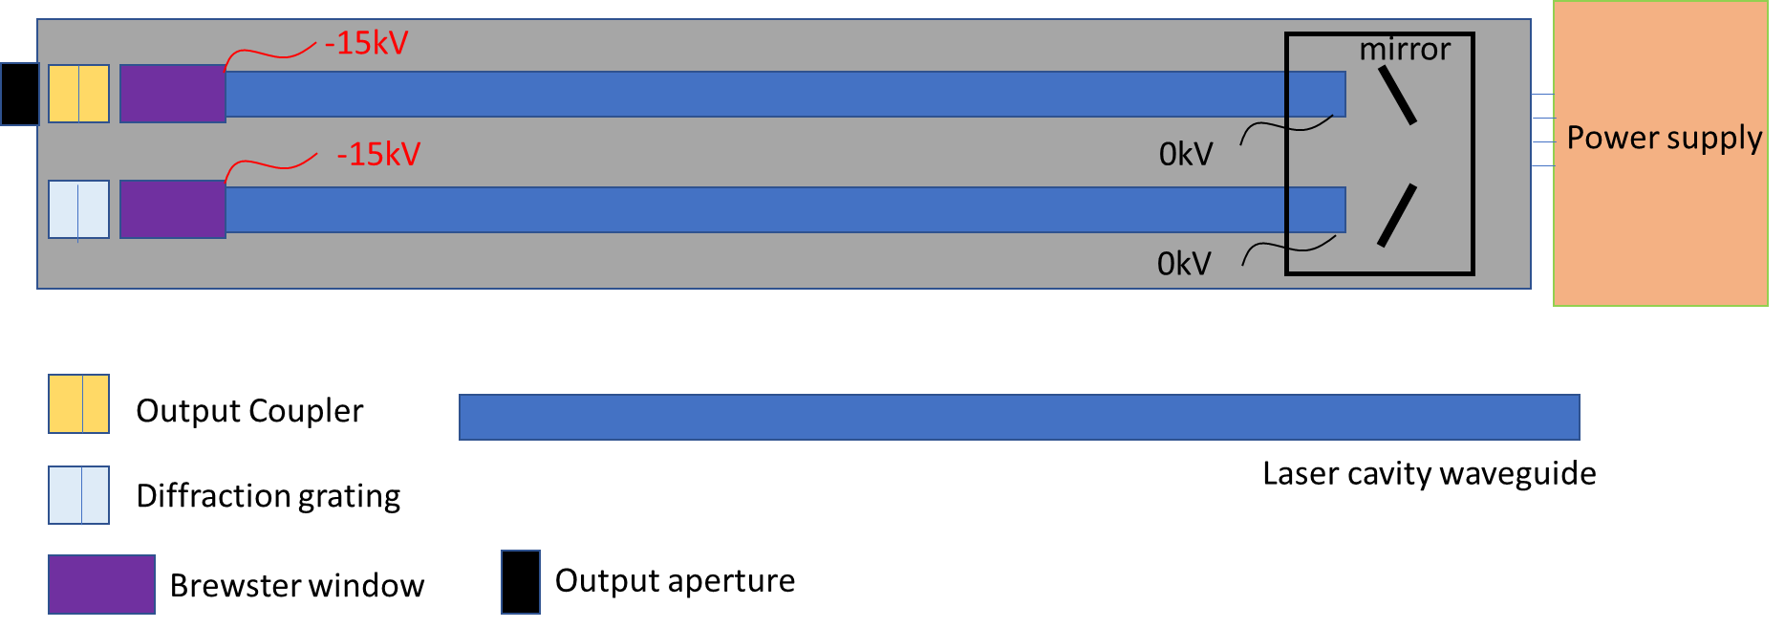

Figure .The main components of the CO2 laser

Figure.2 illustrates the Brewster window and diffraction grating on the PL-6 CO2 laser system. The diffraction grating can adjust the tilt angle via an adjustment knob, with each wavelength corresponding to a specific number on a mechanical counter that is coupled to the grating adjustment. Figure.3 shows the operation panel of CO2 laser, which include the piezo adjustment, gas flow control, gas shutoff knob, cooling water connections, gas inlet port, vacuum port and vacuum isolation valve. The piezo translator is used to adjust the cavity length for maximum output power. The gas flow control system, shown in fig.3(a), regulates the gas flow rate. The vacuum pump, depicted in fig.3 (b), is equipped with a pressure monitor to measure the gas pressure. The laser system is powered by two power supplies from Edinburgh Instruments, each operating at 40 mA and 15 kV under normal conditions. In addition, a cooling circulation system is incorporated to efficiently dissipate heat from the laser system to the external environment.

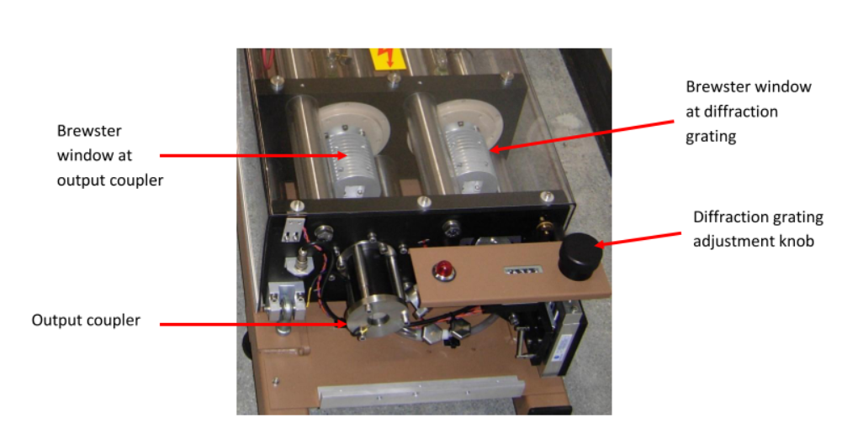

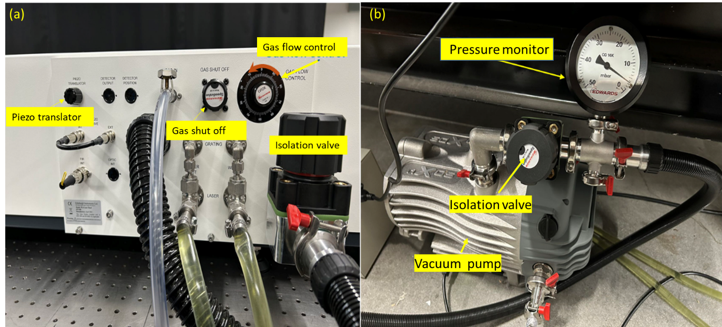Figure . Output end of the PL-6 laser. The Brewster windows, output coupler, and diffraction grating adjustment knob are label

Figure .(a) Laser head control panel. All laser hook-ups are made through this panel including, electrical, gas, vacuum, and water. The gas shut off and flow control are located at the upper right. The PZT controls at the upper left. (b) vacuum pump with pressure monitor

* **FIR system**

The schematic of the FIR system is shown in Fig.4 . The system consists of a rear mirror, a dielectric waveguide tube, a front mirror, and a metallic mesh. The rear mirror is a copper mirror coated with gold, featuring a central hole to allow the CO₂ laser to pass through. The front mirror is a dielectric-coated silicon wafer, designed to provide high FIR transmission (98%) and high CO₂ laser reflection (99%)2. The metallic mesh has a density of 300 lines per inch (lpi), with 20% transmission and 80% reflection for FIR radiation at a 432 μm wavelength9.

The front mirror and metallic mesh are mounted on a stage that can be adjusted along the waveguide axis, driven by a stepper motor. The CO₂ laser oscillates between the front and rear mirrors, while the FIR laser oscillates between the metallic mesh and the rear mirror. By adjusting the cavity length between the metallic mesh and the rear mirror, the output power can be optimized to its maximum value.

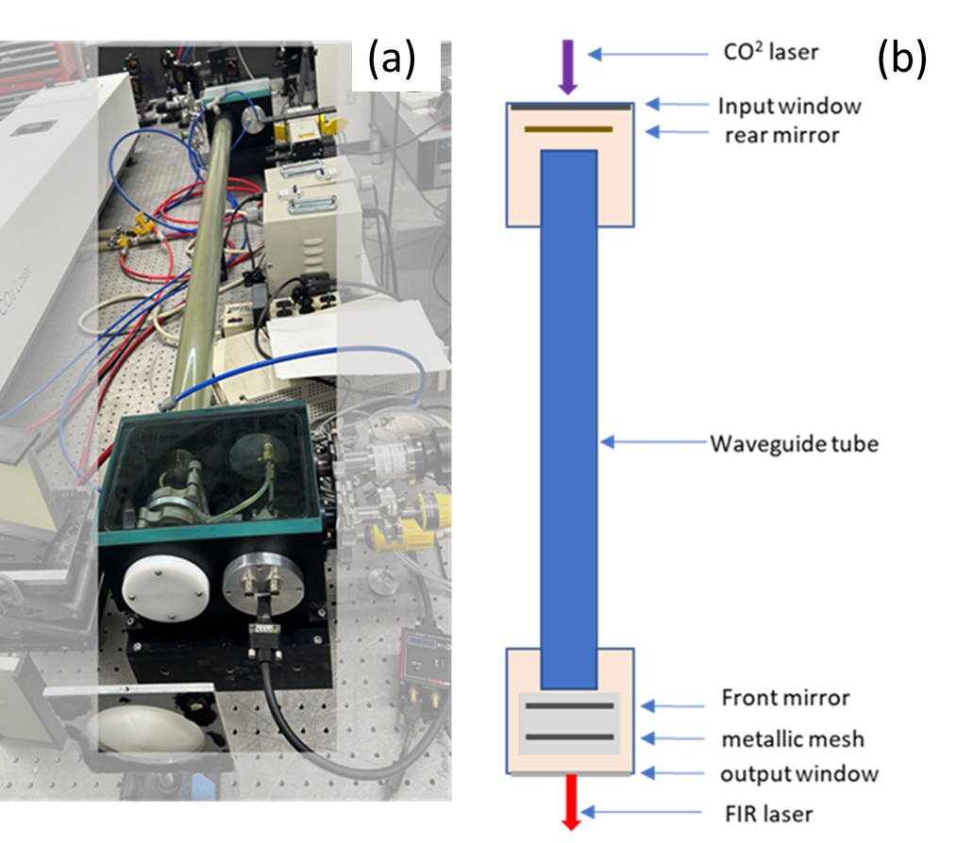

Figure .Overview of FIR system formic acid laser (a) Real picture of FIR laser system. (b) Schematic layout of FIR laser system.

* **The combined system**

As shown in fig.5, the laser system consists of a CO₂ laser system, a FIR laser system with a focusing lens, and a reflector mirror, which facilitates coupling the CO₂ laser into the FIR system. The CO₂ laser beam has a diameter of approximately 11 mm at the output coupler, while the FIR input window has a diameter of 10 mm. Therefore, a focusing lens with focal length of approximately 1 m is necessary to direct the CO₂ beam into the FIR system. The CO₂ beam at focus point is located between the input window and the rear mirror as shown in fig.4(a), where its diameter is reduced to about 3 mm. With the CO2 laser beam filling the FIR waveguide, the formic acid gas will be stimulated and emit the FIR laser continuously.

However, the FIR laser beam profile and intensity are strongly influenced by the optical setup and alignment. Even a minor misalignment of 0.1° can result in a significant alteration of the beam profile. Therefore, precise alignment is crucial to ensuring optimal beam quality and intensity.

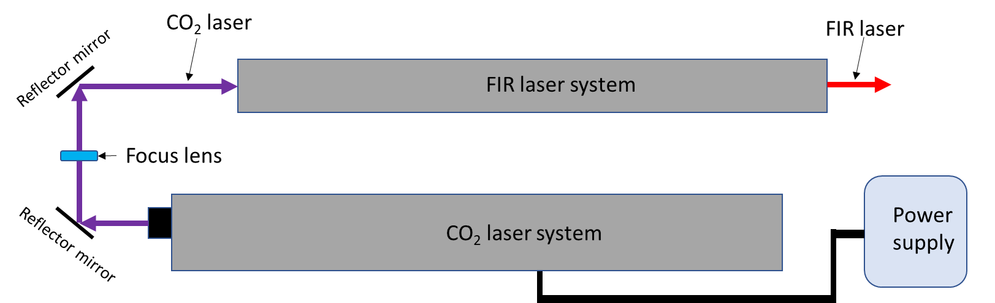

Figure . The overview of the laser system setup

**Optical alignment setup**

To maximize the FIR laser's output power and ensure an optimal beam profile, the CO₂ laser should be precisely aligned with the FIR laser waveguide axis. Additionally, the mirrors in the FIR laser system must be perpendicular to the waveguide axis to facilitate multiple reflections and support the dominant FIR wave mode, EH11​, which results in a Gaussian beam profile at the output.

(1). CO2 laser alignment

The system alignment is setup as shown in fig.6. Since the CO₂ laser is invisible to the human eye, a HeNe laser is used to align the CO₂ laser with the FIR laser system. The HeNe laser is positioned several as far as practical from the output of the FIR laser system, approximately 4.8 m in this case. To allow the visible laser to pass through unobstructed, the metallic mesh, front mirror, rear mirror and lens are temporarily removed. Alignment guides are temporarily placed in the input and output ports to aid in beam alignment. The guides were made from black Delrin, to achieve a snug fit in the bore with a pinhole drilled in the center. The HeNe laser is finely adjusted to ensure that the beam passes through the center of both the input and output windows.

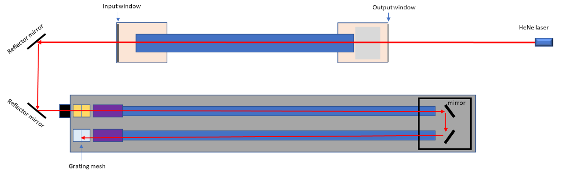The visible laser beam is then reflected into the CO₂ laser output window using two reflector mirrors. The second mirror should be temporarily rotated back and forth, so that the correct height is achieved for entering the CO₂ laser, and adjusted so that it is parallel to the optical table. If the beam does not pass through the center of the CO₂ laser output window, the CO₂ laser system should be repositioned to align the window center with the visible laser. This alignment requires removing the laser cover. Another Delrin guide is used in the end of the output coupler to determine when the beam is centered. If the footprint is not centered on the grating, the CO₂ laser system position should be carefully adjusted to ensure the laser is hitting the center of the grating. This can be a tedious process, as it requires vertical axis rotation, translation, and elevation adjustment of the CO₂ laser. A laser level can be used in conjunction with the HeNe to adjust the elevation of the CO₂ laser. With the lights in the lab off, it is possible to observe reflections of the HeNe laser on the CO₂ laser waveguide, when viewing the reflection from the correct angle. The laser can then be pivoted and recentered, using the output coupler target, to move the reflection down the waveguide until it exits the mirror box and appears on the second waveguide. This process is continued until the faint image of the HeNe can be observed on the grating. With the FIR system and the CO₂ system aligned using a HeNe laser, the CO₂ laser is co-axial with the FIR waveguide tube. This alignment maximizes the CO₂ laser's reflections within the FIR waveguide tube, thereby enhancing absorption and energy transfer to the formic acid gas.

Figure . CO2 laser alignment setup

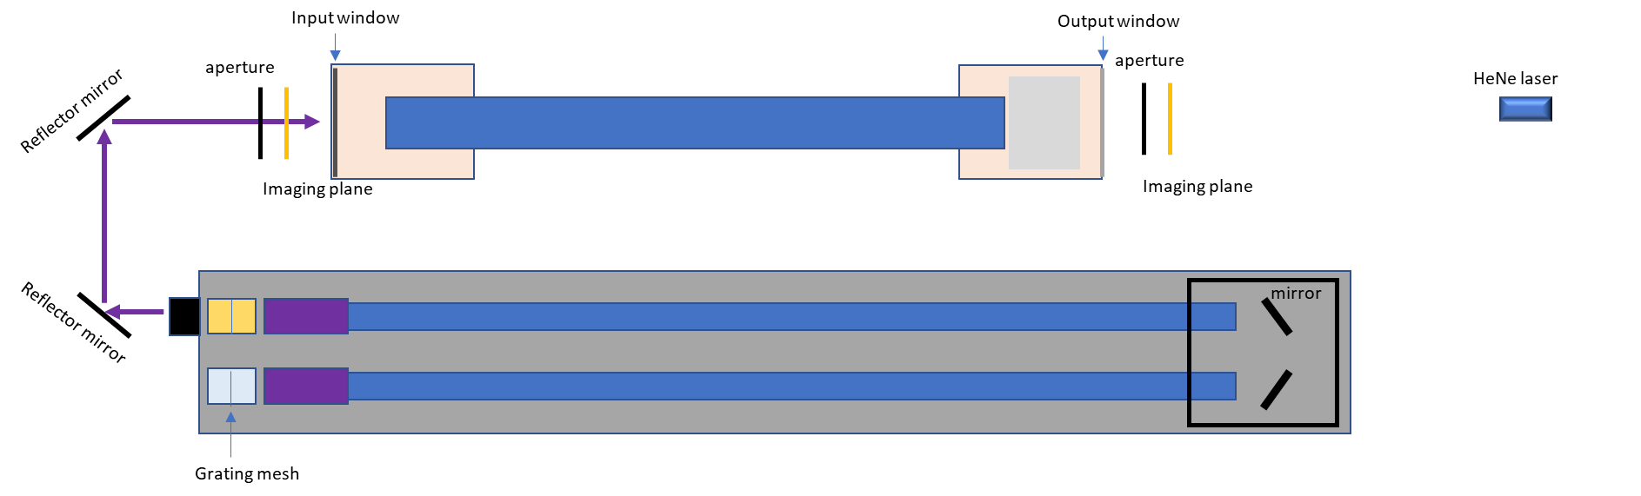

Figure .CO2 laser alignment benchmark

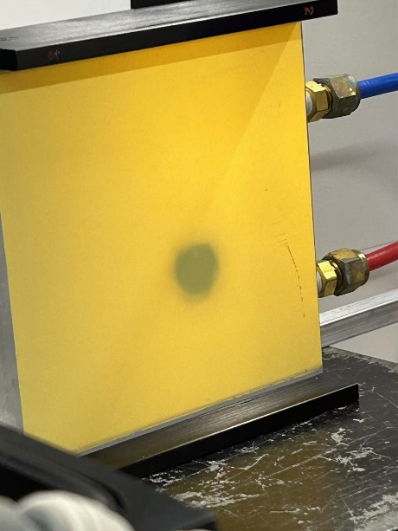

Figure .The imaging of the CO2 laser beam profile

To verify the alignment of the CO₂ laser with the FIR system, two adjustable apertures are positioned in front of the input window and behind the output window of the FIR laser system. The center of each aperture is aligned with the axis of the HeNe laser path. An imaging plate is used to illustrate the CO₂ beam profile as shown in Fig. 8.

The alignment procedure is as follows: first, the apertures are fully opened, and the CO₂ laser is turned on to check whether the beam profile aligns with the HeNe laser optical path at both positions. The method involves gradually reducing the aperture size and examining the clipped beam profile. If the beam profile is symmetrically clipped, the CO₂ beam is aligned with the main optical axis. If asymmetry is observed, the beam is shifted toward the side where more clipping occurs. By checking the beam position at both locations and making slight adjustments to the mirror angle, the CO₂ beam can be aligned with the axis of the visible laser.

(2) Mirror alignment in the FIR laser system

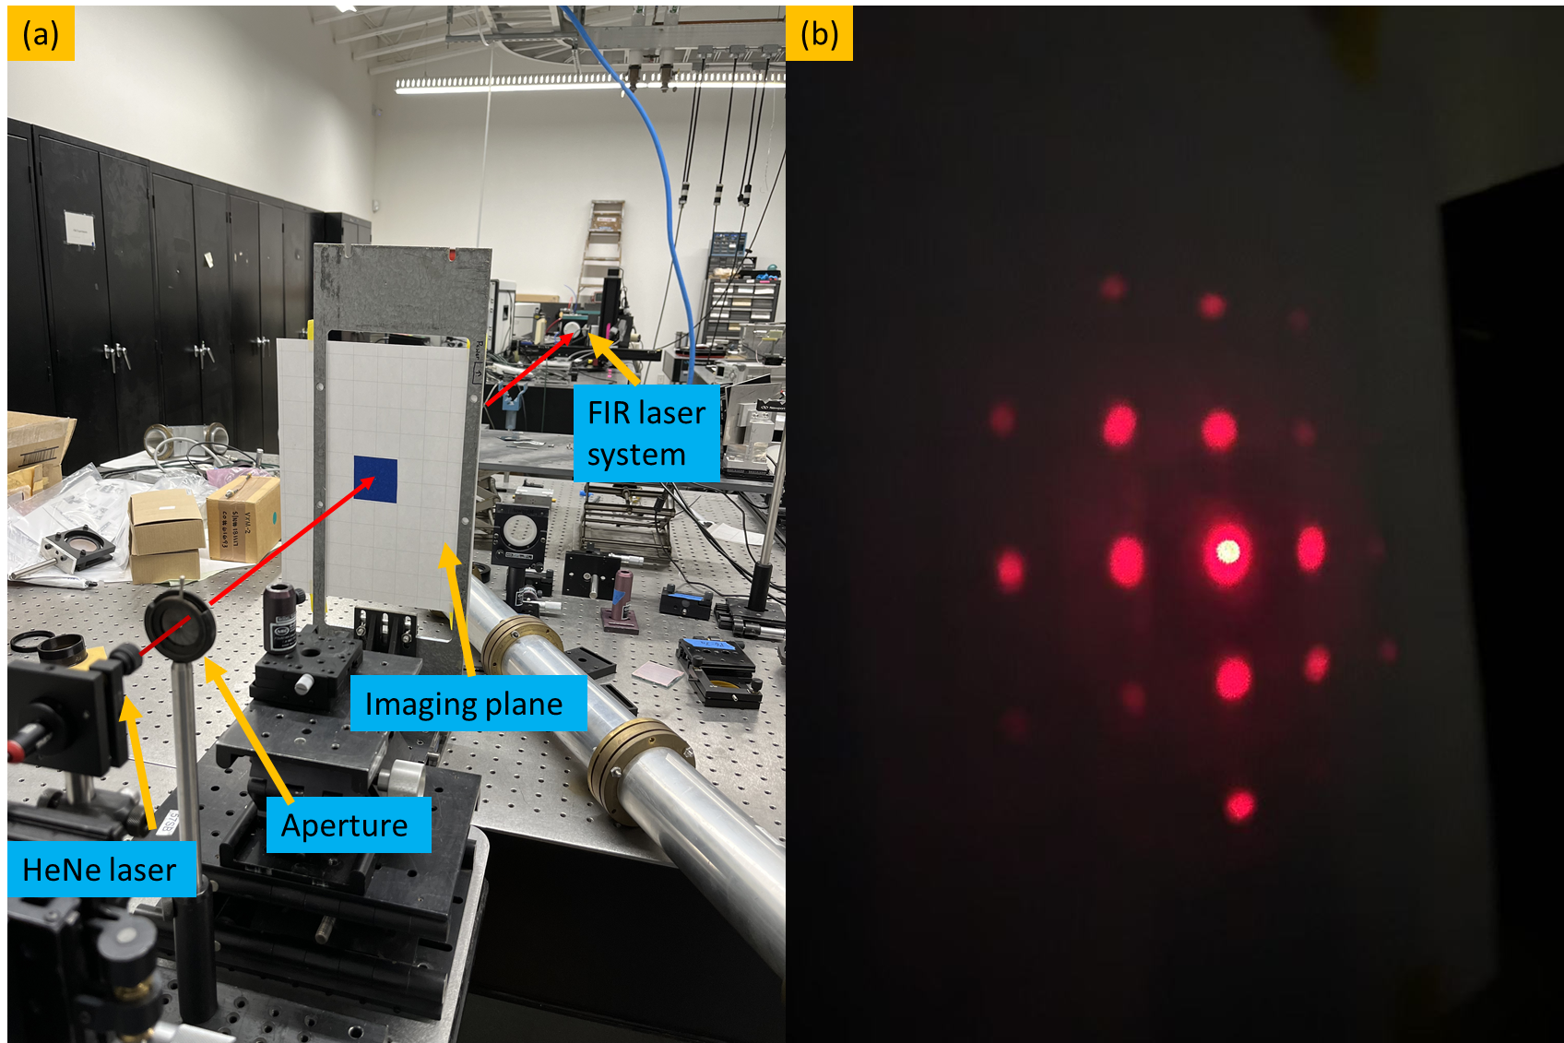

Figure .(a) FIR laser system alignment setup. (b) diffraction pattern on imaging plane from the metallic mesh

The mirror inside the FIR laser system is aligned based on the reflection of the HeNe laser. As shown in Fig.9(a), an imaging plane with a small aperture is positioned in front of the HeNe laser to allow the reference beam to pass through. The distance between the imaging plane and the output window is approximately 3.5 m, ensuring high-precision angular alignment in 0.1 degree.

The alignment procedure begins with the installation of the rear mirror, which contains a central aperture to transmit the CO₂ laser. The rear mirror is carefully positioned so that its center coincides with the HeNe laser beam. As the diameter of the HeNe laser beam is slightly larger than that of the aperture, Fraunhofer diffraction is observed on the imaging plane. By adjusting the rear mirror to align the central diffraction pattern with the aperture on the imaging plane, it can be ensured that the rear mirror is perpendicular to the optical axis.

Similarly, the front mirror reflects the HeNe laser, and its alignment is optimized by adjusting its angle until the reflected beam precisely overlaps with the central aperture on the imaging plane. For the metallic mesh, alignment is achieved by modifying its angle until the zero-order diffraction pattern coincides with the central aperture on the imaging plane, as shown in Fig.9 (b).

**FIR laser adjustment and measurement**

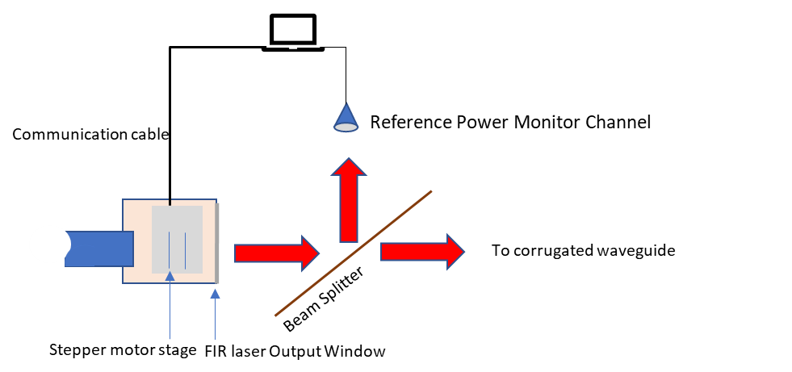Figure .FIR laser cavity adjustment setup

Since the beam intensity is highly sensitive to the cavity length, maximum output power can only be achieved under resonance conditions. Therefore, cavity adjustment is necessary during operation. Figure. 10 illustrates the cavity adjustment setup for optimizing beam power. A beam splitter with a 10:1 intensity ratio is used, where the reference channel utilizes the lower-intensity portion to monitor power variations, while the main power is used for diagnostics. A computer analyzes the power evolution and controls the stepper motor stage, which adjusts the cavity length accordingly.

As shown in Fig.11, the FIR laser intensity varies with the scanning of the cavity length. The peak-to-peak distance is approximately 216 µm, which is about half of the wavelength (432.6 µm). Furthermore, when zooming in on a single peak structure, small fluctuations are observed with a periodicity close to a quarter of the CO₂ laser wavelength (9.5 µm).

The difference between the FIR and CO₂ laser resonance structures originates from their distinct boundary conditions. For the FIR laser, the resonant space is defined between the metallic mesh and the rear mirror, both of which can be approximated as perfect electric conductors. This results in the boundary condition ${k_{1}d}_{1}=nπ$, leading to a resonance spacing of $Δd_{1}=\frac{π}{k}=\frac{λ_{1}}{2}$, where k1​ is the wavevector of the FIR laser, n is an integer number, $λ_{1}$ represents the FIR wavelength and d1 is the distance between the boundaries.

In contrast, for the CO₂ laser, the resonant space is between the front and rear mirrors, with the front mirror being a dielectric wafer. This modifies the resonance condition to $2{k_{2}d}_{2}+ϕ=nπ$, where d2 is the resonant cavity length, k2 is the wavevector of the CO₂ laser, and $ϕ$ accounts for the phase shift upon reflection from the front mirror surface. Consequently, the resonance spacing is given by $Δd_{2}=\frac{λ_{2}}{4}$, where $λ_{2}$ represents the CO2 laser wavelength, which agrees well with the experimental results.

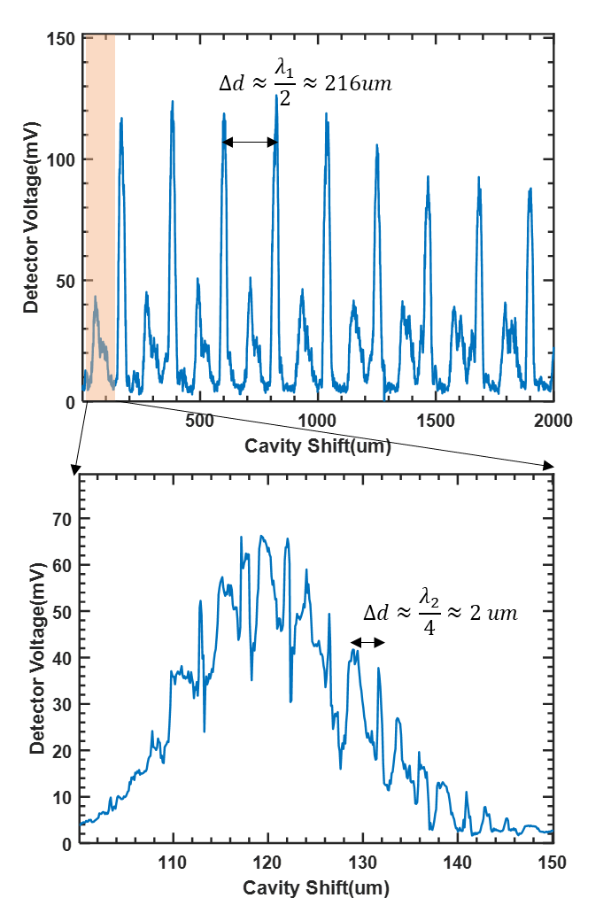

Figure .FIR output intensity with cavity shift measured under Formic acid gas pressure around 150 mTorr

**Intensity instability caused by thermal expansion**

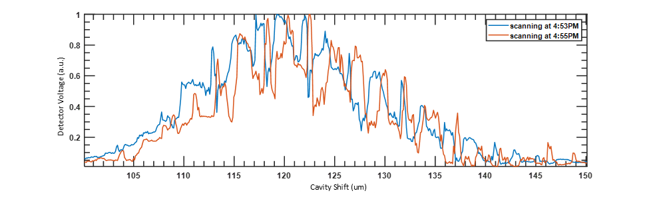

Figure . FIR intensity structure with cavity shift at two different times.

Due to thermal expansion, the FIR intensity structure gradually shifts right over time, in the direction that corresponds to thermal expansion. If the cavity position remains fixed, the intensity fluctuates by approximately 40% within the 2 minutes before the system reaches thermal stability. It typically takes about 2 hours to achieve full thermal stability. This fluctuation introduces uncertainty in distinguishing whether the observed variations originate from plasma dynamics or the system itself, reducing the accuracy of high-k spectrum evolution diagnostics.

**Method to keep intensity stability**

1. increase the HCOOH gas pressure

Since the strong fluctuation is caused by CO₂ laser resonance, one way to mitigate it is by increasing the formic acid gas (HCOOH) pressure. Higher HCOOH pressure enhances CO₂ laser absorption, reducing the resonance effect and resulting in a smoother FIR intensity structure. As shown in Fig.13, once the pressure exceeds 190 mTorr, the fluctuation becomes significantly smaller. However, as the pressure increases, the maximum intensity also decreases. To balance intensity and fluctuation, we choose P around 221 mTorr as the optimal pressure.

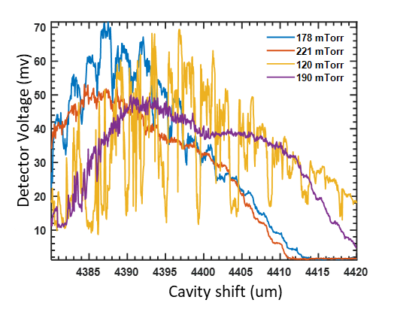

Figure .Scanning Cavity under different gas pressure

1. setup the feedback control system

The main resonance structure of the FIR laser also shifts to the right due to thermal expansion, leading to an intensity drop if the cavity remains stationary. To address this, a feedback control system is implemented for automatic cavity optimization. The system continuously monitors the power of FIR, and once the intensity drops to 80% of its original value, it drives the stepper motor to adjust the position of the mesh and front mirror, shifting the cavity to the right to find the optimal position. Controlled by LabVIEW, the system integrates the power monitor, a Thorlabs stepper motor, and a host computer. It operates automatically to maintain the cavity at its optimal position, with each adjustment process taking approximately 10 seconds. The maximum power of FIR is approximately 50 mW, which is measured by an absolute power meter.

**Beam profile measurement**

The beam profile is measured using a self-developed auto-scanning stage system. This system includes a power detector with a window diameter of approximately 5 mm and a three-stepper motor stage that drives the optical stage in the X, Y, and Z directions. As shown in fig.14, two power monitors are used—one for power measurement and the other for reference power measurement at a fixed position. The real beam profile would be demonstrated as the distribution of Pscan/Pref, where the Pscan refers to the scanning channel power at each point while the Pref refers to the power on reference channel at each point. This approach helps compensate for power fluctuations during the measurement. A power detector with a chopper, positioned in front of the FIR window at approximately 300 mm, measures a 20 mm × 20 mm range in the X-Y direction with a step size of 2 mm.

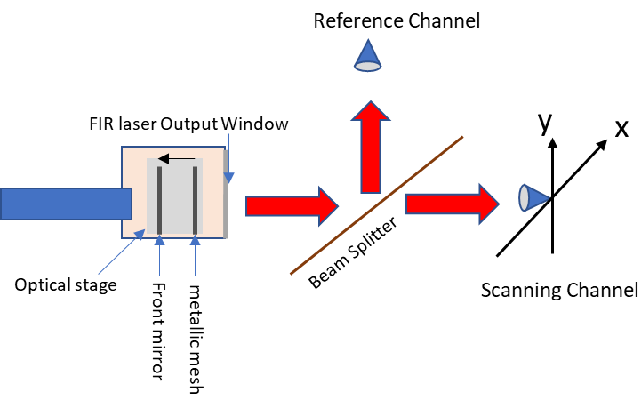

Figure . Beam profile measurement setup

The beam profile appears as shown in fig.15 when all mirrors are well aligned. However, it is highly sensitive to the metallic mesh angle—even a deviation of 0.1° can result in a completely different beam profile, as demonstrated in Fig. 16 and 17 . Here, zCavity represents the cavity shift along the optical axis. Each time the mesh angle is adjusted, the cavity must be reset to its optimal position before measuring the beam profile. The diffraction pattern observed on the imaging plane can be used to evaluate the metallic mesh angle. Given that the distance from the imaging plane to the mesh is approximately 3 meters, a displacement of about 3 mm from the zero-order spot to the center hole (which allows the reference laser to pass through) corresponds to a mesh angle deviation of roughly 0.06° relative to the reference laser. However, the beam profile varies significantly depending on the direction of this deviation, highlighting the extreme sensitivity of the mesh angle to alignment adjustments. Consequently, aligning the mesh requires meticulous precision and, at times, even a bit of luck. The most practical solution is to position the mesh outside the vacuum chamber, which could make laser alignment much easier.

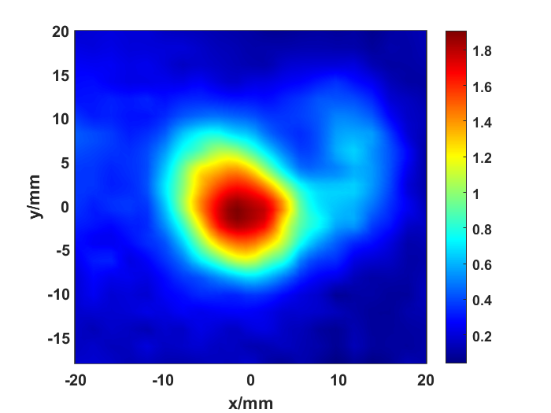

Figure .FIR beam profile

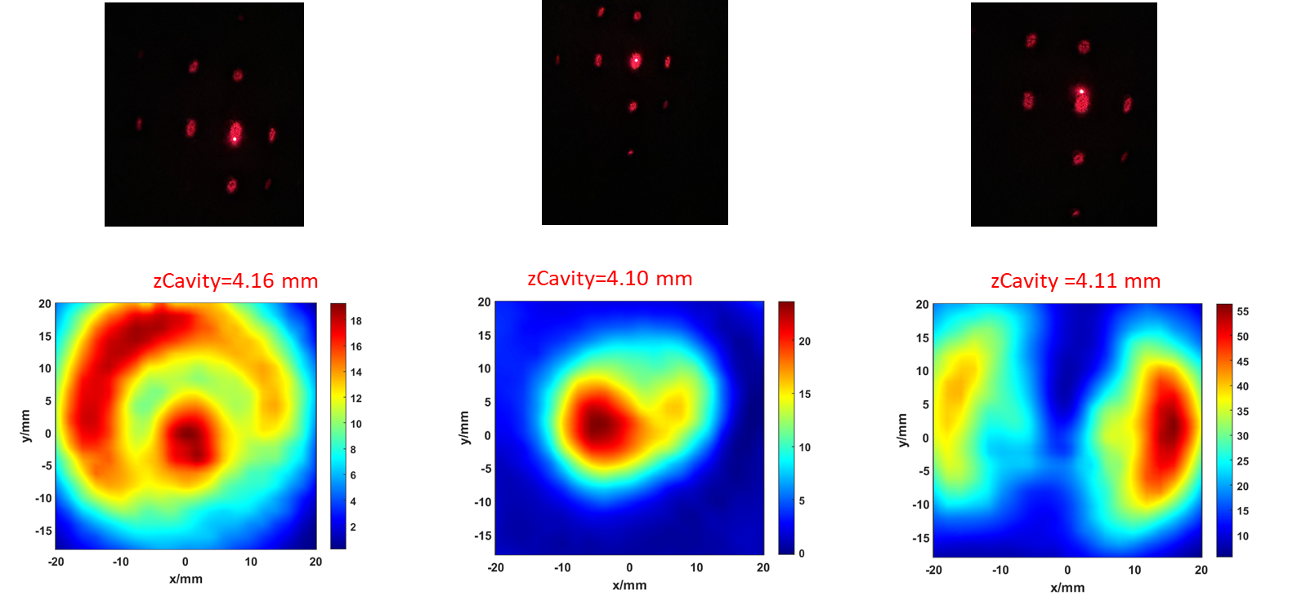

Figure .Beam profile for zero-order diffraction pattern at Upper, near center and below of the center.

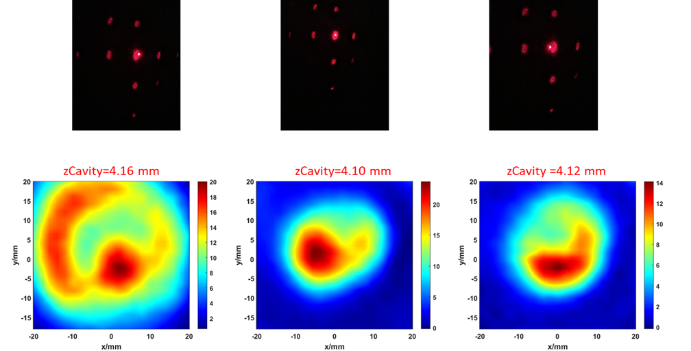

Figure Beam profile for zero-order diffraction pattern at left, center and right of the center

**Reference:**

1.Qi, Lei. "Energy transfer of trapped electron turbulence in tokamak fusion plasmas." *Scientific Reports* 12.1 (2022): 5042.

2.Barchfeld, Robert Adam. “*Development of Laser Based Plasma Diagnostics for Fusion Research on NSTX-U”*. 2017.

3.Domier, C. W. “A poloidal high-k scattering system for NSTX-U”. *Journal of Instrumentation* 17.01 (2022): C01018.

4: Liu, Xianzi, et al. "Quasi-optical beam tracing module development for millimeter-wave high-wavenumber collective scattering on the NSTX-U and EAST tokamaks." Fusion Engineering and Design 212 (2025): 114826.

5.Liu, Xianzi, et al. "The National Spherical Torus Experiment-Upgrade poloidal high-k scattering system pitch angle design modifications." *Review of Scientific Instruments* 93.10 (2022).

6. Dangoisse, D., and P. Glorieux. "The optically pumped formic acid laser." *Reviews of Infrared and Millimeter Waves: Volume 2 Optically Pumped Far-Infared Laser*. Boston, MA: Springer US, 1984. 429-465.

7.Jacobsson, Stellan. "Optically pumped far infrared lasers." *Infrared physics* 29.5 (1989): 853-874.

8. Mukhopadhyay, Indranath, and Shyam Singh. "Optically pumped far infrared molecular lasers: molecular and application aspects." *Spectrochimica Acta Part A: Molecular and Biomolecular Spectroscopy* 54.3 (1998): 395-410.

9. Deng, Bihe, et al. "Innovative high-gain optically pumped far-infrared laser." *Applied Optics* 55.21 (2016): 5580-5584.